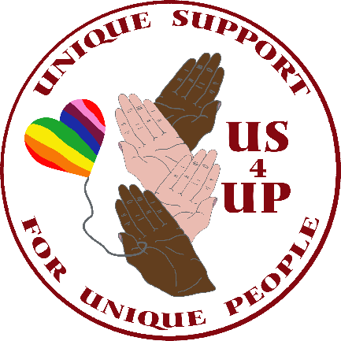

Equality and Diversity Policy

Unique Support for Unique People (US4UP) aims to encourage, value and manage diversity and is committed to providing equality for all.
Unique Support for Unique People wishes to secure genuine equality of opportunity in all aspects of its activities.

Unique Support for Unique People is committed to eliminating discrimination and encouraging diversity amongst individuals. Equality and diversity will be considered in all activities and resources. This policy will be implemented within the framework of current legislation ‘Equality Act 2010’.

Purpose
The purpose of this policy is to provide equality and fairness for all in the service delivery and to eliminate discrimination on grounds of:

Gender (including sex, marriage and civil partnership, pregnancy and maternity, gender re-assignment)
Women and men are fully and properly represented without discriminating against their gender.

Individuals are treated fairly and equally irrespective of their marital/civil partnership or family status. US4UP will take positive steps to support a transgender person and ensure they are treated with dignity and respect.

Race (including ethnic origin, colour, nationality and national origin)
The racial and cultural diversity of the local community is represented through:
- challenging racial stereotypes
- understanding, respecting and valuing racial and cultural difference and perspectives
- encouraging and enabling members of minority ethnic groups to work with US4UP at all levels

Disability
The abilities of disabled people are recognised and valued through:
- focussing on what people can do rather than on what they cannot
- challenging stereotypes about people with disabilities and in particular, not making false assumptions that disabled people are unable to do certain things
- making appropriate adjustments in the workplace so that people can reach their full potential regardless of any disability.

Sexual orientation
People are treated fairly irrespective of their sexuality through:
- respecting the rights of everyone irrespective of whether or not they are open about their sexuality
- respecting different lifestyles even if someone’s different lifestyles conflicts with one’s own religious or cultural beliefs
- challenging negative stereotypical views
- celebrating and welcoming significant lesbian, gay, bisexual and transgender (LGBT) events in the same way that similar events of importance to heterosexual people are celebrated

Religion or belief
People are treated fairly irrespective of their religious beliefs, faith or lack of belief. Demands of religion (e.g. prayer times and religious holidays) and of culture (traditional dress) are accepted.

Age diversity is promoted and valued through:
- challenging age stereotyping, recognising that the new ideas and fresh approaches can come from anyone irrespective of their age
- recognising the benefits of mixed- age workers

Eliminating discrimination

Discrimination occurs when a condition or requirement is applied which cannot be justified. Forms of direct discrimination include less favourable treatment (denial of access to or a poor level of service), harassment or victimisation, or creating an environment that is intimidating, hostile, degrading, humiliating or offensive. Harassment occurs when someone's actions or words, based on the relevant grounds, are unwelcome and violate

Unique Support for Unique People will not tolerate harassment in any form and in particular:

Racial harassment is unlawful. Incidents include:
- physical assaults/threats against a person or group because of colour or ethnicity
- racist insult/joke/name calling
- racist graffiti/any other written insult
- provocative behaviour (e.g. wearing racist badges or insignia)
- racial comments in meetings conversation/workshops
- attempting to recruit for racist organisations or groups
- racist literature (leaflets, comics, magazines) providing a platform for racism

Sexual harassment is unlawful. The definition adopted by Unique Support for Unique People is:
- Repeated and unwanted verbal or sexual advances, sexually explicit derogatory statements or sexually discriminating remarks which are offensive to the person involved, which cause them to feel threatened, humiliated, patronised or harassed or which creates a threatening or intimidating environment.

Harassment against disabled people is unlawful to subject a disabled person to harassment by engaging in unwanted conduct which has the purpose or effect violating the disabled person's dignity, or creating an intimidating, hostile, degrading, humiliating or offensive environment for him/her.

Victimisation means treating someone less favourably because they have made a complaint of discrimination or are thought to have done so; or because they have supported someone else who has made a complaint of discrimination.

Indirect discrimination occurs where the effect of provisions, criteria or practices imposed by an employer have an adverse impact disproportionately on one group or other. Indirect discrimination generally occurs when a rule or condition, which is applied equally to everyone, can be met by a s m a l l e r proportion of people from a particular group; the rule is to their disadvantage and it cannot be justified on other grounds.
Unique Support for Unique People will seek to overcome indirect discrimination by provision of information about relevant support organisations.

Responsibilities
US4UP’s commitment to equality and diversity means that the service has a duty to:
promote equality and diversity in the delivery of Unique Support for Unique People services to
ensure that everyone associated with US4UP is treated in a non-discriminatory way
- promote a welcoming environment in which individuals from all backgrounds feel welcome, valued and respected
- promote this equality and diversity policy

Unique Support for Unique People:
- ensure systems, procedures and services do not discriminate
- promote and implement diversity within the management of service provision
- complete appropriate training to put this equality and diversity policy into practice
- challenge inappropriate behaviour immediately
- listen to and respect others, and not dismiss their problem
- set a positive example in everything they do

Policy to be reviewed October 2022

